**Project Portfolio**

[**441183_A24_T2: Fundamentals of Robotics**](https://canvas.hull.ac.uk/courses/74645)

**Wiktor Biesiadecki 202421412**

**University of Hull 2025**

**Task 1 – Creating a door-locking system**

1.1 Introduction

First task consisted of programming and construction challenge to develop door locking system based on Arduino board. The finished project uses RFID module to inform the board that card is present and upon presenting correct card it operates the servo that moves the latch. The system provides user feedback via an LCD display.

1.2 Materials and components

Following components were used for door lock assembly:

-breadboard

-mini breadboard

-RFID module

-SG90 Micro Servo

-sliding door lock

-solid base

-16x2 lcd display

-potentiometer

-Arduino UNO R3

-jumper wires

-metal wire

-USB-B cable

1.3 Design

1.3.1 Construction

Servo motor together with sliding door lock were securely attached to the base and connected with metal wire in such way servo can push and pull lock handle closing and opening it.

1.3.2 Circuitry

LCD display was attached directly to mini breadboard using pre-soldered male connectors, then pins were further connected to main board and Arduino using male-male jumper wires. Main breadboard was connected to RFID module and potentiometer for display’s contrast. Power was supplied by USB-B cable connected to PC.

1.3.3 Software

The Arduino code utilizes three libraries Servo.h to control servo motor, MFRC522.h for interfacing with RFID module and LiquidCrystal.h for managing display.

In the setup() function, the libraries are initialized, pin modes are set, and the servo is moved to the initial 'locked' position.

The main loop() function continuously checks for an RFID card presented to the reader. It reads the card's UID and compares it to the stored authorized UID. The unique ID (UID) of the authorized RFID card is defined within the code.

Based on the comparison result, appropriate messages ("Door Locked", "Access Denied", "Door Open") are displayed on the LCD, and the servo motor is instructed to either remain in the locked position or move to the unlocked position for a set duration before automatically re-locking. (Refer to Task1-WB.ino for the full source code).

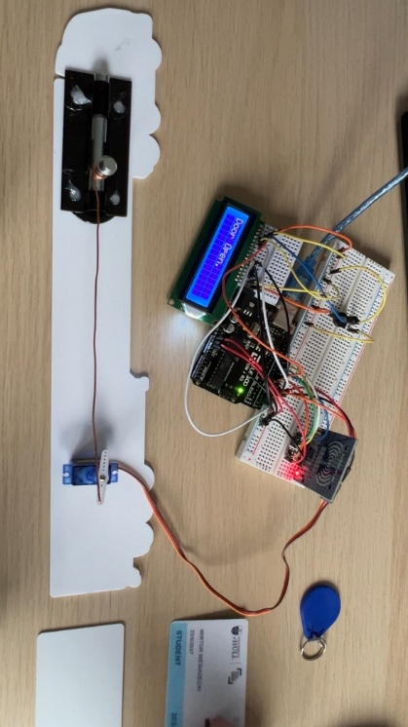1.4 Implementation

All components were assembled as per picture below (pic.1) and wiring was connected as below (pic.2)

Pic.1

Pic.2

* 1. Functionality

Initially upon starting the device the door remains locked and screen displays “Door Locked”. When scanner is presented with invalid card/fob lock will remain locked and screen will display “Access Denied” message for 2 seconds then “Door Locked” will be displayed again. When presented with correct card signal will be sent to servomotor to move 180 degrees opening the lock. The screen will display “Door open” and after 3.5 second the lock will automatically lock again. Now the loop will go back to the initial state, and we can present the card again.

Below flowchart represents how the code works:

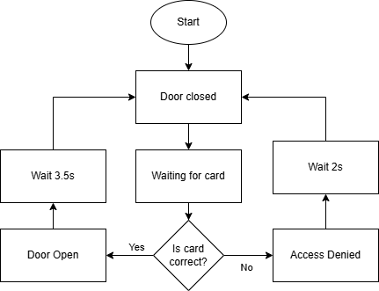

Presentation video is available in Task1-WB folder. File name is Task1-Presentation.

* 1. Testing and results

To ensure correct functionality of code and hardware number of test were conducted using two different cards and one fob. Device managed to detect correct card with 100% accuracy and consequently servomotor managed to open the lock via the linkage. Correct message was displayed on the screen as well.

On top of that tests conducted with incorrect mediums were 100% successful. Lock remained locked and LCD display displayed correct message.

* 1. Challenges and Solutions

As the main challenge in this project I would list properly aligning servo, with servo arm and linkage connected to the lock itself to ensure smooth operation. Copper wire was helpful as it’s more malleable than steel equivalent.

* 1. Conclusion

In conclusion I can definitely say project was a success. It successfully demonstrated integration of RFID module, LCD display and servo motor into a functioning door lock while meeting all initial goals.

**Task 2 – Autonomous Arduino Robot**

2.1 Introduction

Second task consisted of programming and construction challenge to develop autonomous Arduino Robot. The finished project resulted in robot moving with help of two servomotors which can find a path around obstacles using ultrasonic sensor to determine available directions of travel. Robot utilises RFID scanner to start and stop operation as well as RGB led indicate its status. Robot is powered by 9V battery. 3D printed parts were used as motor mounts, Arduino board holder and cage to protect its components in case of colliding with any objects.

2.2 Materials and components

Following components were used to assemble the robot:

-round base plate

-wheel X2

-servomotor X2

-3D printed motor mounts

-3D printed Arduino holder

-3D printed protective cage

-Arduino board

-9V battery

-battery cable

-RGB LED

-RFID module

-Ultrasonic sensor module

-mini breadboard

-jumper wires

-hardware (screws)

- resistor 220 Ω X3

2.3 Design

2.3.1 Construction

Custom components (motor mounts, Arduino holder, protective cage) were designed using Tinkercad (Pic. 3, 4, 5, 6) and 3D printed on university printers. All 3D printed parts are secured to the round base using screws. These parts facilitate the mounting of motors, the Arduino board, and sensors onto the round base plate, while the cage offers protection. 9V battery is mounted centrally between motors.

(Refer to Pic. 7, 8, 9, 10 for assembly details).

**

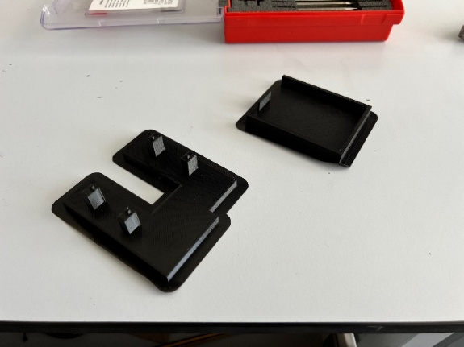Pic.3 Pic.4

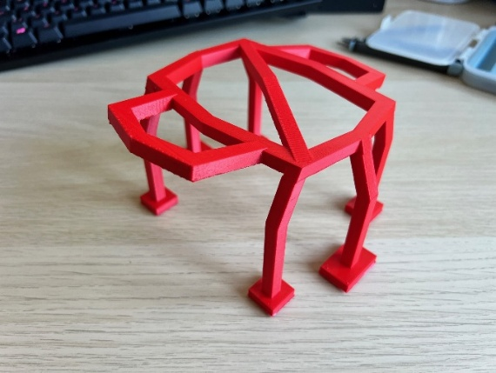

Pic.5 Pic.6

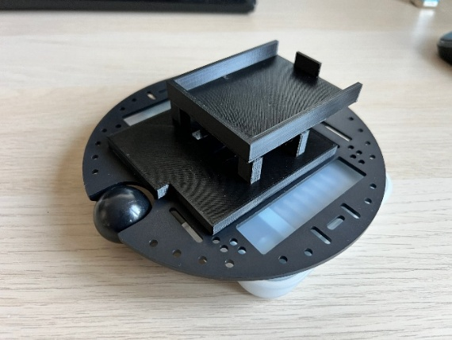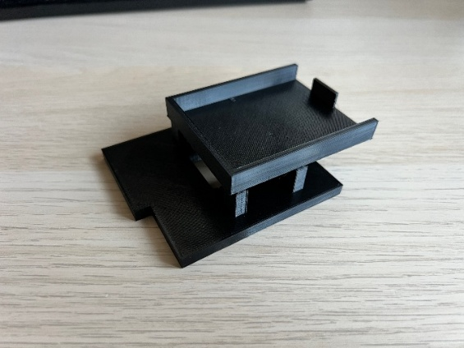

Pic.7 Pic.8

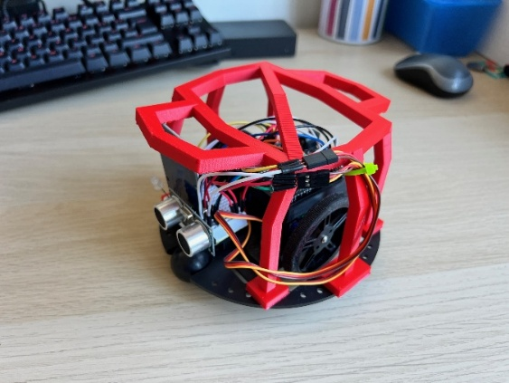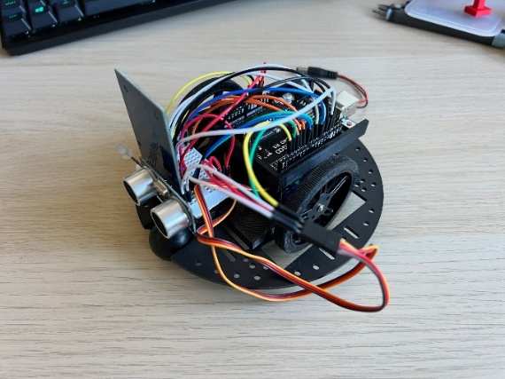

Pic.9 Pic.10

2.3.2 Circuitry

Components were wired using a mini breadboard and jumper wires. Sonar, RFID module and status LED are connected directly to mini breadboard. LED is using 3 220Ω resistors. All components connect to Arduino by jumper wires connect to breadboard. Ground 5V and 3.3V for all components is taken from shared terminals on breadboard. 9V battery is user as power supply connect to Arduino board by barrel jack. (Refer to Pic. 11 for the detailed wiring diagram).

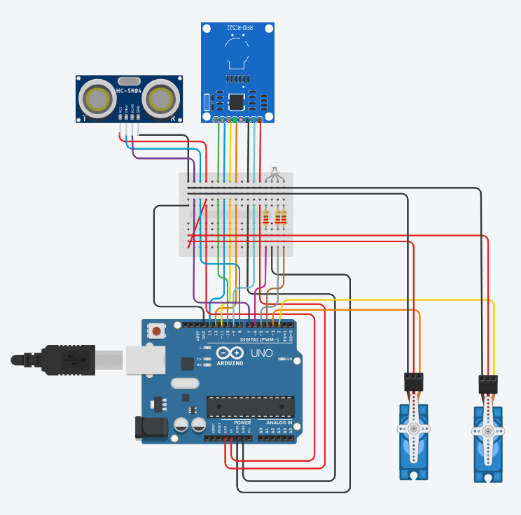

Pic.11

2.3.3 Software

The Arduino sketch integrates libraries for the key components: Servo.h (for controlling wheel servos), MFRC522.h (for RFID), and HCSR04.h (or equivalent for the ultrasonic sensor).

* The setup() function initializes serial communication, sensors, RFID reader, and sets initial LED status (Red). The authorized RFID card UID is defined.
* The loop() function first checks for RFID card presentation. If the correct card is scanned, the robot enters an 'active' state (Green LED). If an incorrect card is scanned, the LED blinks Red.
* While 'active', the robot continuously measures distance using the ultrasonic sensor.
* If distance > 15cm, the robot moves forward at normal speed (Green LED).
* If 5cm < distance <= 15cm, the robot slows down (Yellow LED).
* If distance <= 5cm, the robot stops, turns randomly left or right using the random() function for decision-making (Red LED during turn), and then resumes forward motion checking.
* Presenting the correct RFID card again while active will stop the robot (returning it to the idle Red LED state).

(Refer to the provided flowchart for code logic and Task2-WB.ino for the full source code)

2.4 Implementation

The 3D printed parts were produced, and all components were assembled onto the base plate using hardware as shown in the pictures (Pic. 7-10). Wiring was completed according to the diagram (Pic. 11). The Arduino was programmed with the final code via USB before switching to battery power.

2.5 Functionality

When powered on via the 9V battery, the robot remains stationary with the RGB LED illuminated Red (idle state).

* **Start:** Presenting the correct RFID card changes the LED to Green, and the robot begins moving forward.
* **Wrong Card:** Presenting an incorrect card causes the Red LED to blink several times, and the robot remains idle.
* **Moving forward:** Robot moves forward in straight line until obstacle is detected
* **Obstacle Detection:**
  + Approaching an obstacle (between 15cm and 5cm): LED turns Yellow, robot slows down.
  + Very close to an obstacle (<= 5cm): LED turns Red, robot stops, executes a random turn (left or right), then resumes forward movement with Green LED (if path is clear).
* **Stop:** Presenting the correct RFID card again stops the robot and returns it to the idle Red LED state.

2.6 Testing and Results

Robot works correctly in principle and in majority of situations during testing. Due to simplistic nature of the robot and implementation of only one static sonar sensor aiming directly ahead, detection of obstacles on the side is problematic as well as avoiding obstacles when approaching them at sharp angles. In this situations robot can on occasion turn into obstacle again (for example when approaching the wall) In controlled environment when obstacles are placed at 90° no unintended behaviour occurred.

Robot starts and stops using correct card. Reliable and consistent obstacle detection at 15cm and 5cm. Robot can navigate through obstacles or labyrinths with wall ideally placed at 90°. Due to lack of its environment data stored in memory on occasion robot backtracks to starting point.

Depending on surface turn were not always accurate especially when while initiating turn each wheel where on different surface (one on carpet, one on wooden floor).

2.7 Challenges and Solutions

During printing of one 3D printed part print failed due to hardware issue. On second try layer adhesion problem occurred, but part was repaired using soldering iron to fuse it together.

Calibrating the continuous rotation servos for reliable turns proved challenging as they had to be correctly timed. Final solution was achieved with trial-and-error method.

2.8 Conclusion

The autonomous robot project successfully integrated RFID control, ultrasonic sensing for navigation, and motor control as well as use of 3D printed parts. The robot demonstrated basic autonomous obstacle avoidance capabilities as intended meeting all initial goals.

**References**

DIY Engineers (n.d.) RFID Arduino – Read RFID Tag’s UID with RC522 <https://www.diyengineers.com/2021/04/15/learn-how-to-read-an-rfid-tag-with-rc522-and-arduino/> [Accessed 08 Mar 2025]

University of Hull (n.d.) Arduino Ultrasonica <https://canvas.hull.ac.uk/courses/74645/files/5898725?module_item_id=1295155>

[Accessed 29 Mar 2025]

gamegine, NdK, Mitsuaki Fukuzaki (2018) HCSR04-ultrasonic-sensor-lib <https://github.com/gamegine/HCSR04-ultrasonic-sensor-lib?tab=readme-ov-file> [Accessed 29 Mar 2025]